Subject: New Content and Features Available in the BAI Learning Manager

We are excited to announce new content and functionality recently made available in the BAI Learning Manager designed specifically to help you excel in your role at ‘Org Name'! For the first time, you have access to a new library of documents and resources that includes regulation overviews, checklists, red flags, whitepapers, videos, job aids and much more. Sample topics covered include:
- “Completing a CTR”
- “Mortgage Origination Checklist”
- “Fair Lending Considerations: Avoiding Discrimination”
- “Elder Financial Abuse Red Flags”

This new content was made available with new features in the BAI Learning Manager designed to help you easily search, browse and heart important documents for quick reference in the future. A new My Documents area has been added to the Student Dashboard that will display all your assigned and hearted documents. Thus, allowing you to keep frequently used items front and center.

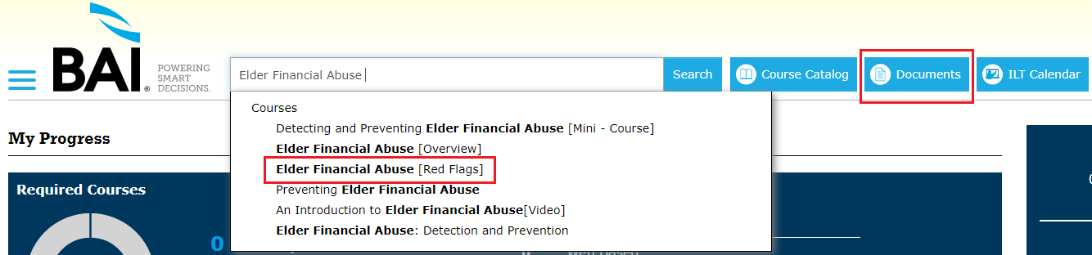

These enhancements were developed with the input of a panel of BAI’s clients. BAI regularly looks to its customers for recommendations on new content and improvements to the Learning Manager. Your feedback is always welcome and can be provided via the ‘Submit Feedback’ icon in the Help Center on the Student Dashboard.

